5/15/2024
Wednesday, May 15, 2024
8:29 AM

Attendees: Lisa Hoffmann. Marie Stelmack, Alkema Jackson, Andrea Shearer, Ash Lane, Kat Acosta, Rebecca Ritter, Samir Zahid, Arie Hayre-Somuah, Hanna Mast, Lisa Lefavore, Margaret Flanagan, Hanifah Matumla,

Hypertension Disparity
- Latest PDSA is scorecards
  - Teams doing own PDSA
    - Purple Team using Gaps report in Azara to do targeted interventions
    - Steel - BP cuff offering
    - Green - Erin face time with the nurse
    - Yellow - uncontrolled clients to the BP education group
- Deep dive into ordering processes for clients on Medicaid
  - Having all on paper might be able to reduce mental burden in ordering a cuff for client
  - BP group
- QUESTION: option to order Large or XL but up to DME provider or pharmacy

PrEP
- Unified way of documenting - move from prescription fill to new DX CODE
  - Tyler Gray developed order set
- Communications PDSA is PDSA #2
  - Let Marie know if want brochures at community sites
- Next PDSA to develop a cascade of care

Childhood Vaccinations
- Current
  - Doing proactive work to catch clients
  - Flu and Rota are the hardest to get because time limited
- Validating the data is next

Hospital Readmission Rate
- Strengthening the connection between Mercy and HCH
  - Call Center nurse is directly linking with Mercy Transitional Care Team

Depression Remission
- RCA and will be working on the first PDSA
- Focus on disparity we are seeing there with Hispanic and Latinx clients

Colorectal Cancer Screening
- RCA - continuity of care, lab issues, mail in option issues
- Meeting this week to design first PDSA

Appointment Access
- First meeting today!
- Including a client in this subcommittee

Care coordination and diabetes coming up next

PI Tool portion: ways of thinking: divergent to convergent thinking
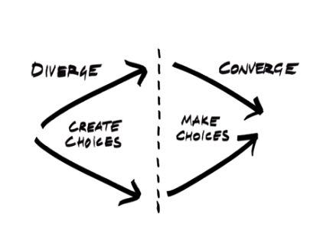
Can get stuck in divergent mode - many ideas without way to implement
Convergent can get stuck and only think about one way to do things
Try implementing both at next meeting.

